SHOUT Inc
Building 1 Pearce Community Centre
Collett Place, Pearce ACT 2607
Ph: 62901984 Email: admin@shout.org.au

Room Hire Fees

SHOUT ‘s meeting room provides a well-lit, comfortable venue with total disability access. Meetings of up to 30 people are easily catered for and the room has a kitchenette, air conditioning, hearing loop and has a wall mounted smart TV for your presentations. It is clean, comfortable, and located in Pearce.

We offer the meeting room at a very reasonable rate and welcome new organisations to view our well-appointed and centrally located venue. Weekends are available, we have good availability as well as days and evenings. Parking is free with extra free parking available at the Pearce Shops opposite.
Hire Rates
 | Type | Hourly rate | Daily Rate
Membership | Corporate Members | $30 | $180
 | Affiliate Members | $35 | $195
 | Member Tenants | $25 | $175
Non -Members | Community | $50 | $200
 | Corporate | $55 | $320

In the meeting room there is an urn and fridge available – if you wish to serve tea and coffee etc you will need to provide your own – mugs, crockery and cutlery are provided. However, if you would like us to cater the rates are below. Please note, catering is only available during SHOUT’s business hours of 9am – 3pm, Monday – Friday.

Hot beverage package: $3 per person (either morning or afternoon, or $5 p/p for both, minimum 4 people)
Fruit and small cake/biscuits: $4 per person (either morning or afternoon, or $6 p/p for both, minimum 4 people)

Numbers for catering are required no less than a week prior to the meeting and cannot be altered after this time.

For availability of dates: Email Elsa at admin@shout.org.au or phone 62901984
Once you have checked the availability of dates, please complete this form and email it along with the Casual Meeting Room Hire Conditions Form attached. Please note: Bookings are available in 30-minute blocks.

Organisation
Community or Corporate
Contact person
Phone Number
Email for invoice
Date required
Meeting start and end time
Catering required
Please note that sporting activities and parties are not suitable
Office use
Booking entered
Completed
Conditions of Hire Agreement 2024
SHOUT Meeting Room
Organisation or Group
Contact Person
Contact Person Position
Mobile Number
Office Number
Email
Email for Invoicing

The Conditions of Hire of the Meeting Room are:
- The SHOUT Meeting Room premises are left tidy, rubbish is disposed of in the bin, recycling is placed in the bin provided and all dishes are washed dried and put away, benches and tables are wiped down. For more detailed instructions please see the following page.
- After the event/meeting the chairs are left in the position they are found – please do not stack multiple chairs as this is an OH&S issue and may cause injury for other hirers. A diagram showing the correct placement of chairs and tables is attached and, also on the notice board in the room.
- If the meeting room is hired for craft activities, you will need to provide plastic tablecloths and placemats for each table that will be used.
- The rate of hire has been reduced to accommodate community groups as a cost-effective option – however this rate is given on the understanding that the room is left clean and tidy and there is no extra cleaning required.
- If SHOUT is required to clean after your event/meeting, your organisation will be billed $100 for the time required to set the room to the appropriate condition.
- The room must be locked at the end of your meeting and if hired on the weekend the building will need to be rearmed upon exit.
- There is a keyless lock that requires pin C2607 to be entered to open the door.
- Lost swipe cards will be charged at $50 each for their replacement.
- Any damage will be notified to SHOUT Inc and is the responsibility of the hirer and by signing this form you agree to pay for any damage incurred. SHOUT will arrange for the damage to be fixed by an approved repairer approved by the Property Management Group.
- SHOUT Inc takes no responsibility for injuries to meeting participants, staff, volunteers or agents within the hours of the hire or within the premises or outside the premises.
- Due to liability issues the Meeting Rooms are not hired for sporting pursuits or parties.
- Alcohol is not permitted to be consumed in the premises and it is agreed that no alcohol is available throughout the hire or taken onto the premises.
- Due to the popularity of the meeting room 48 hours’ notice is required to cancel a booking.
- Meetings should be held in the room for the booked time only – should the meeting be shorter than the allotted time, the invoice will still be charged for the allotted time. If a booking runs overtime, but there is no booking following, the Organisation/ Group will be charged for the extra time in 30-minute blocks, please email SHOUT to advise if this occurs.
- Invoices are sent monthly for room hire – no deposit is required.
- When setting up the Meeting Room – please ensure you allow time in your booking for set up.
- When exiting the Meeting Room, please ensure it is tidy and that you have packed up on time ready for the next group. We ask that you are respectful of the current meeting and keep noise to a minimum while you are waiting for the Meeting Room to vacate. On the reverse – please ensure that your meeting ends on time and the room is set right and vacated promptly.
- SHOUT reserves the right to book the Meeting Room according to its business needs, and members requirements. In not fulfilling the above requirements, and if these requirements are not addressed adequately and/or continue to occur, SHOUT reserves the right to cancel future bookings or refuse bookings.

If you have any concerns about the facilities, please email admin@shout.org.au

Note that all bookings for 2023 require this form to be signed. Meetings will be cancelled if it is not received prior to your first room booking.
SHOUT suggests that you inform all staff and volunteers who book the meeting room of these terms and conditions.
This document must be signed (by hand) by a person who has the authority to sign on behalf of the organisation – CEO, Executive Board Member, Manager or President/Chair.

We fully understand the terms and conditions and our Organisation/Group will comply by this agreement.
Contact Name _____________________________________Position__________________________
Signed____________________________________________ Date____________________________
SHOUT Staff________________________________________ Signed__________________________

Chair and Table Set Up
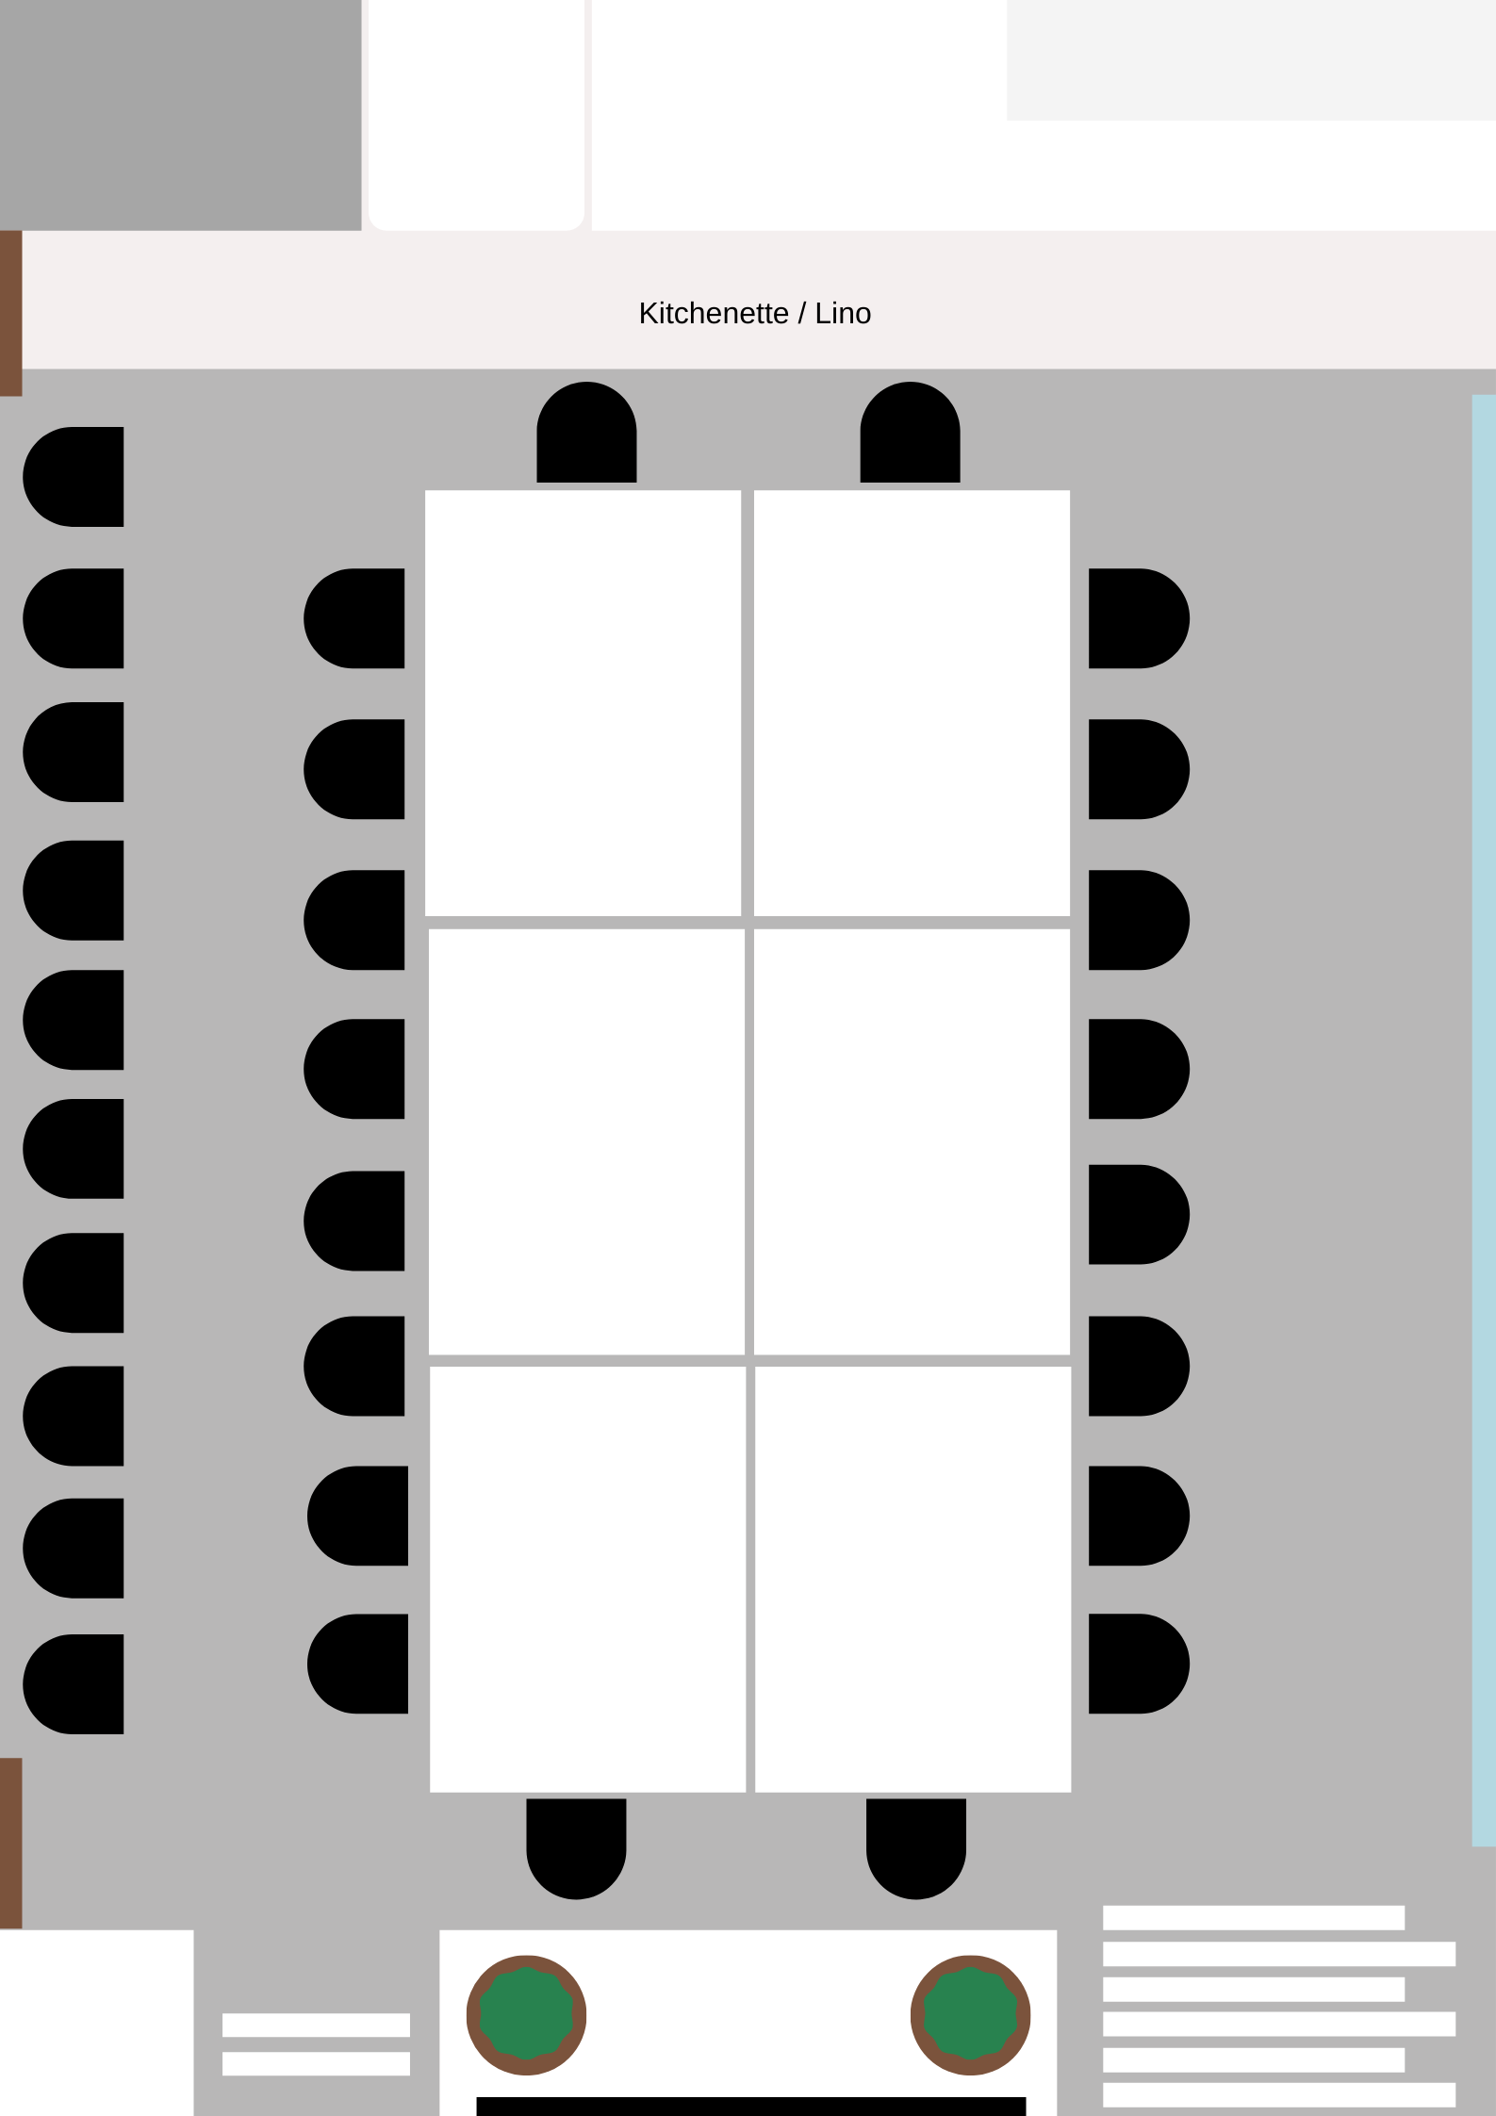

End of Meeting Pack Up
- Dishes washed dried and put away in cupboard
- The kitchen bench wiped down
- Sanitise and clean down tables and put back into position
- Chairs - 8 chairs on both the sides and 2 either end of white tables
- Excess chairs lined on the long wall with no windows
- The trestle tables put back out of the way
- Whiteboards cleaned and put away
- The air conditioner turned off
- Fridge emptied of your food/milk
- If you move anything like plants, please place them back in the position you found them
- Swipes (Casual bookings) placed into the key letterbox
- Alarm set – if booking is on a weekend
Please let SHOUT know if there are any issues.

