SHOUT Inc
Building 1 Pearce Community Centre
Collett Place, Pearce ACT 2607
Ph: 62901984 Email: admin@shout.org.au

Room Hire Fees

SHOUT ‘s meeting room provides a well-lit, comfortable venue with total disability access. Meetings of up to 30 people (COVID 19 conditions apply) are easily catered for and the room has a kitchenette, air conditioning, hearing loop and has a wall mounted smart TV for your presentations. It is clean, comfortable and located in Pearce.

We offer the meeting room at a very reasonable rate and welcome new organisations to view our well-appointed and centrally located venue. Weekends are available, we have good availability as well as days and evenings. Parking is free with extra free parking available at the Pearce Shops opposite.
Hire Rates
 | Type | Hourly rate | Daily Rate
Membership | Affiliate Members | $25 | NA
 | Full Members | $20 | NA
 | Corporate Members | $20 | NA
Non -Members | Community | $35 | $175
 | Corporate | $40 | $280

In the meeting room there is an urn and fridge available – if you wish to serve tea and coffee etc you will need to provide your own – mugs, crockery and cutlery are provided. However if you would like us to cater the rates are below.

Hot beverage package $2.50 per person each (either morning or afternoon - $4.50 both)
Fruit and small cake/biscuits $3.00 per person (either morning or afternoon - $5.50 both)
Numbers for catering are required no less than a week prior to the meeting and cannot be altered after this time.

For availability of dates: Email Elsa at admin@shout.org.au or phone 62901984
Once you have checked the availability of dates, please complete this form and email it along with the Casual Meeting Room Hire Conditions Form attached. Please note: Bookings are available in 30-minute blocks.

Organisation
Community or Corporate
Contact person
Phone Number
Email for invoice
Date required
Meeting start and end time
Catering required
Please note that sporting activities and parties are not suitable
Office use
Booking entered
Completed
Conditions of Hire Agreement
SHOUT Meeting Room
Organisation or Group
Contact Person
Contact Person Position
Mobile Number
Office Number
Email
Email for Invoicing

The Conditions of Hire of the Meeting Room are:
- The SHOUT Meeting Room premises are left tidy, rubbish is disposed of in the bin, recycling is placed in the bin provided and all dishes are washed dried and put away, benches and tables are wiped down. For more detailed instructions please see the following page.
- After the event/meeting the chairs are left in the position they are found – please do not stack multiple chairs as this is an OH&S issue and may cause injury for other hirers. A diagram showing the correct placement of chairs and tables is attached and also on the notice board in the room.
- The rate of hire has been reduced to accommodate community groups as a cost-effective option – however this rate is given on the understanding that the room is left clean and tidy and there is no extra cleaning required.
- If SHOUT is required to clean after your event/meeting, your organisation will be billed $100 for the time required to set the room to the appropriate condition.
- The room must be locked at the end of your meeting and if hired on the weekend the building will need to be rearmed upon exit.
- There is a keyless lock that requires pin 2607 to be entered to open the door.
- Lost swipe cards will be charged at $50 each for their replacement
- Any damage will be notified to SHOUT Inc and is the responsibility of the hirer and by signing this form you agree to pay for any damage incurred. SHOUT will arrange for the damage to be fixed by an approved repairer approved by the Property Management Group.
- SHOUT Inc takes no responsibility for injuries to meeting participants, staff, volunteers or agents within the hours of the hire or within the premises or outside the premises.
- Due to liability issues the Meeting Rooms are not hired for sporting pursuits or parties.
- Alcohol is not permitted to be consumed in the premises and it is agreed that no alcohol is available throughout the hire or taken onto the premises.
- Due to the popularity of the meeting room 48 hours’ notice is required to cancel a booking.
- Meetings should be held in the room for the booked time only – should the meeting be shorter than the allotted time, the invoice will still be charged for the allotted time. If a booking runs overtime, but there is no booking following, the Organisation/ Group will be charged for the extra time in 30-minute blocks, please email SHOUT to advise of this instance
- Invoices are sent monthly for room hire – no deposit is required.
- When setting up the Meeting Room – please ensure that you allow time in your booking for set up, especially if the room is booked prior. SHOUT usually endeavours to provide 30 mins between bookings if available, however this is not always possible.
- When exiting the Meeting Room, please ensure it is tidy and that you have packed up on time ready for the next group. We ask that you are respectful of the current meeting and keep noise to a minimum while you are waiting for the Meeting Room to vacate. On the reverse – please ensure that your meeting ends on time and the room is vacated promptly.
- SHOUT reserves the right to book the Meeting Room according to its business needs, and members requirements. In not fulfilling the above requirements, and if these requirements are not addressed adequately and/or continue to occur, SHOUT reserves the right to cancel future bookings or refuse bookings.
- Throughout the Covid-19 period, in order to have the maximum capacity of 30 in the room, each organisation is required to provide their own, or sign the attached COVID Action Plan before their first booking. It is also a requirement to download the CBR check in app and scan the QR Code when you arrive for your meeting. This applies to each individual who enters the meeting room.
- For any concerns about the facilities email admin@shout.org.au
Note that all bookings for 2021 require this form to be signed, as well as a COVID Action Plan. Meetings will be cancelled if it is not received prior to your first room booking.
SHOUT suggests that you inform all staff and volunteers who book the meeting room of these terms and conditions.
This document must be signed (by hand) by a person who has the authority to sign on behalf of the organisation – CEO, Executive Board Member, Manager or President/Chair.

We fully understand the terms and conditions and our Organisation/Group will comply by this agreement.
Contact Name _____________________________________Position__________________________
Signed____________________________________________ Date____________________________
SHOUT Staff________________________________________ Signed__________________________

Chair and Table Set Up
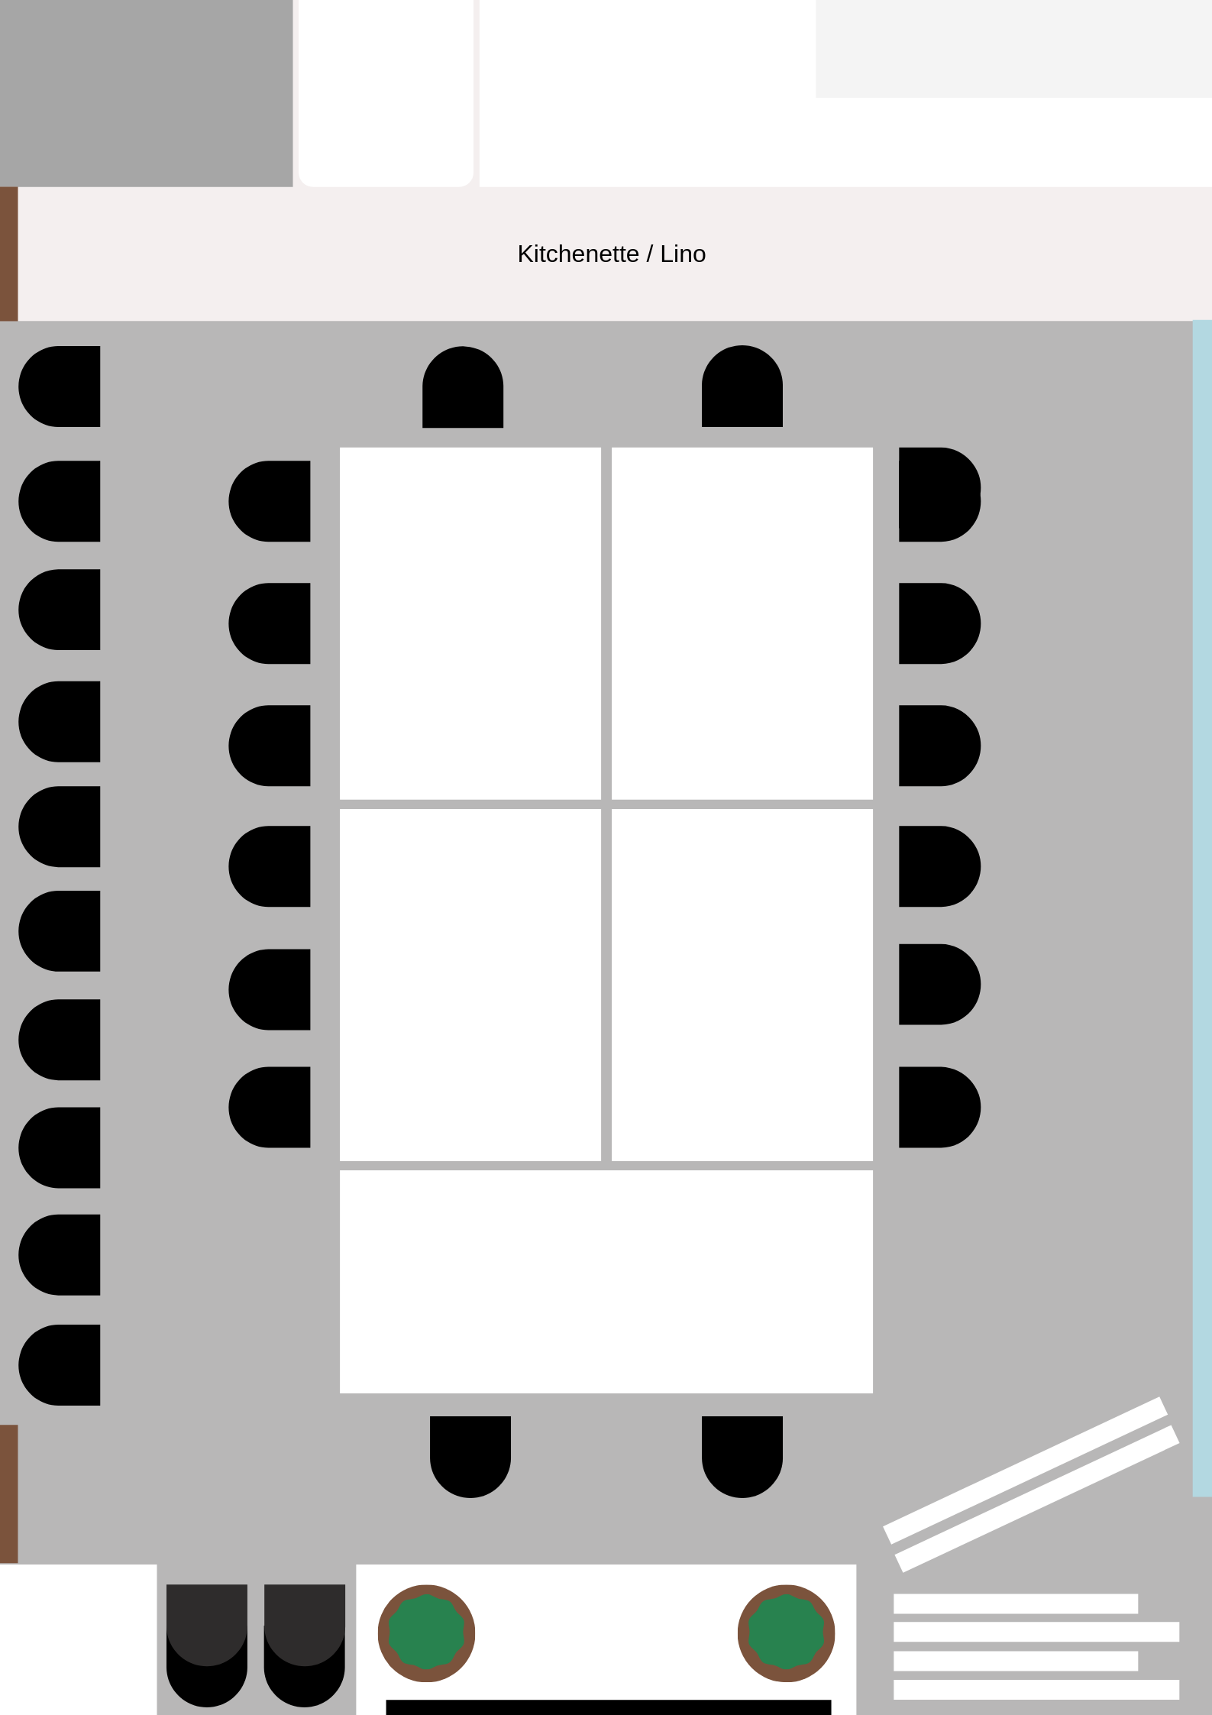

End of Meeting Pack Up
- Dishes washed dried and put away in cupboard
- The kitchen bench wiped down
- Sanitise and clean down tables (as per Covid-19 requirements) and put back into position
- Chairs - 6 chairs on both the sides and 2 either end of white tables
- Excess chairs lined on the long wall with no windows
- The trestle tables put back behind the white boards out of the way
- Whiteboards cleaned off
- The air conditioner turned off
- Fridge emptied of your food, milk
- If you move anything like plants, please place them back into their position where you found them
- Swipes (Casual bookings) placed into the key letterbox
- Alarm set if weekends
Please let SHOUT know if there are any issues.

2021 SHOUT Meeting Room Hire COVID 19 Action plan

Name of Organisation
Contact Name
Phone
Email

SHOUT will accept this document as proof of a COVID plan for Meeting Room hire for 2021. Alternatively SHOUT will accept organisations COVID plan as long as they include the terms below.
The grey column below must be ticked on every line and the form signed for the meeting room booking to comply with the COVID safe requirements by ACT Government. The COVID plan will allow organisations to book the room for dates in 2021 and have up to 30 participants in the room, including presenters.
Please note that non-compliance of the COVID restrictions places both your participants and SHOUT at risk of serious financial consequences in fines – and will result in your organisation being liable to pay the fines and to be refused meeting room bookings in the future.
We agree  (Please tick) | What we agree to the following terms:
 | We will refuse entry to any participant or presenter who is demonstrating COVID symptoms, or has a member in the family with COVID symptoms
 | We will refuse entry to any participant or presenter who is waiting for test results or who has visited a hotspot within the past 14 days
 | We will inform SHOUT if there are any incidences of a positive COVID test who attended the group as soon as practical
 | We will ensure that all participants will check-in using the CBR sign app in on a smart phone. If a person does not have a smart phone, another person may add that person as a guest for the meeting on their smart phone
 | We will ensure that participation numbers are limited to 30 in the Meeting Room including presenters
 | We will ensure that every participant or presenter will use hand sanitiser on entry of the Meeting Room
 | We will ensure that every participant or presenter keep as much personal distance as possible (ideally 1.5 metres) with no hugging or touching
 | We understand that if catering is provided, buffet food is avoided and single serves used as much as possible to avoid contact
 | We will ensure that the tables are wiped down with disinfectant and paper towels at the end of the session and the room is left tidy

We agree to the COVID Plan for hiring the SHOUT Meeting room and will comply with the terms in this document.
Name_______________________________________________ Signed__________________________________
Date_________________________________

