Annual Report 2019 2020

Name, Job title
Company name
Date
someone@example.com
Statement of Purpose
Our purpose is to support and connect community groups with the Canberra community by building capacity and opportunity.
Vision
A fair and just community, which is enriched by self-help.
Mission
Our mission is to support community groups through connection, skill development, awareness and governance to deliver vital outcomes to their members.


Our Community
SHOUT supports, builds and connects with community organisations, charities and groups within the health, disability and support sectors.
SHOUT Believes in social justice and a fair go for all people of all abilities and ages.
SHOUT values and embraces diversity.
SHOUT believes that people sharing , supporting and assisting one another, increases connection, reduces isolation and has lasting health benefits for the individual and all the community.

Board Members
Corporate Members
The Personnel Group
Advocacy for Inclusion
Arthritis ACT
Australasian College of Road Safety
Borderline Personality Disorder Awareness
Diabetes NSW and ACT
Australian Breast Feeding Association ACT
Carers ACT
Cancer Council ACT
Directions Health
Flourish Australia
Women With Disabilities ACT
Epilepsy ACT
ADACAS
Imagine More
Pandsi
Retire Invest
Perinatal Wellbeing Centre (formerly PANDSI)
NEDA
Rotary Daybreak
Anglicare
Skipper Care
Koomarri
Multiple Sclerosis ACT
Hartley Lifecare
Auto Immunne Australia
Australian Medical Association ACT
LDK

Full Members
- ACT Down Syndrome Association
- Bosom Buddies
- Motor Neurone Disease
- Brain Tumour Alliance Australia
- People with Disabilities ACT
Parkinsons ACT
- Canberra and Queanbeyan ADD Association
- Prostate Cancer Support Group
- ACT ME/CFS Society

Rebecca Davey – Chair
Shannon Kolak – Vice Chair
Jon Stanhope – Community Advocate
Khalid Ahmed – Treasurer
Peter Moore – Secretary
Libby Steeper – Board Member
Linda Spurrier – Board Member

Staff
Carol Mead – CEO
Elsa Aitchison – Office Coordinator

Natasha Reardon – Administration Assistant

Acknowledgements
ACT Government
Minister Suzanne Orr
Minister Shane Rattenbury
Property Management Group
Pearce Community Centre
Nexis Accounting

Hardwickes Auditing
LAN ID
Zsuzsa Painting
Queanbeyan Carpets
Reach for Training
ABS Landscapes
OHomes
Integral Printing
Green and Gold Nursery Gold Creek

SHOUT Tenants
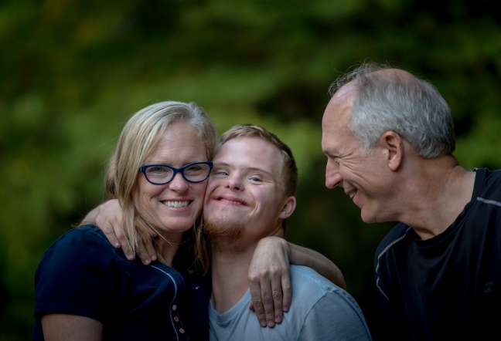
ACT Down Syndrome Association
Arthritis ACT
ME / CFS
Bosom Buddies
MND Association NSW
Brain Tumour Alliance Australia
Affiliate Members
Al-Anon
AIRA
Spinal ACT
Canberra Kidney Support Association
ACT Deafness Resource Centre
Adoptive Families Association ACT
Better Hearing Australia - Canberra
Canberra Lung Life Support
Health Care Consumers ACT
Haemophilia Foundation ACT
Hepatitis ACT
Mental Health Foundation
Sleep Apnoea
Solace ACT Inc
Sharing Places
Mindful Self Compassion
Roundabout
Yoga for Birth and Beyond

Full Members
ACT Down Syndrome Association
Bosom Buddies
Motor Neurone Disease
Brain Tumour Alliance Australia
Parkinsons ACT
Canberra and Queanbeyan ADD Association
Prostate Cancer Support Group
ACT ME/CFS Society

Corporate Members
The Personnel Group
Advocacy for Inclusion
Arthritis ACT
Australasian College of Road Safety
Borderline Personality Disorder Awareness
Diabetes NSW and ACT
Australian Breast Feeding Association ACT
Carers ACT
Cancer Council ACT
Directions Health
Flourish Australia
Women With Disabilities ACT
Epilepsy ACT
ADACAS
Imagine More
Pandsi
People with Disabilities ACT
Retire Invest
Perinatal Wellbeing Centre (formerly PANDSI)
NEDA
Rotary Daybreak
Anglicare
Skipper Care
Koomarri
Multiple Sclerosis ACT
Hartley Lifecare
Auto Immunne Australia
Australian Medical Association ACT
LDK


Chief Executive Officer Report

This year has been one of good success and many interesting challenges which has really tested our capacity to move with change though a very interesting unprecedented period of COVID-19. If the drought, fires and hailstorm were not enough to begin the 2020 year, certainly COVID-19 was something none of us were prepared for.

Just prior to the end of 2018/2019 we secured further funding to progress the ILC Web of Support into the next financial year – which was a relief and enabled us to ensure that the platform was reviewed and updated prior to the end of funding.
Promotional activities and marketing SHOUT and our members was substantial in 2019 and gave great results for all and definitely was worth the time spent on the activities to promote the community sector. We participated in expos and events representing our members to the community and had great success in ensuring the Web of Support was a point of contact throughout the year for all Canberrans.
Administration services for our members have been extremely successful and through this period a total of 6 organisations, in varying capacity have taken up our administration support program. In addition many members have taken advantage of our Strategic Planning capacity building opportunities for their organisations. We managed to finalise 7 Strategic Planning Days until CoVID-19 affected us all.
As mentioned above we have had a number of challenges in this year, not only have environmental factors but also the economy and how we operate. Specifically COVID-19 has enabled SHOUT to look at process and o find new and innovative ways to working to meet the needs of the members through other means of communication and support. During this time a number of issues have been very much part of the landscape of dealing with workplace stress and HR issues, this has very much been a focus of HR support through the shutdown and return to work period.
SHOUT has supported several key charitable initiatives throughout this past year – Share the Dignity, The Bushfire Appeal, and Animal Rescue activities through ARC. SHOUT is actively involved in Days for Girls International assisting and providing girls around the world access to washable feminine hygiene products to break the chains of the cycle of poverty.
While COVID-19 has challenged htwe way we work, one light at the end of the tunnel has been securing funding for the Pearce Inclusive Community Garden and also receiving assistance from the ACT Government to further fund infrastructure such as paths and garden beds to extend the garden further than the first idea. Our next challenge is to start the vegetable garden so we can really work on this feature.
I thank my staff, Elsa and Natasha, for their work and professionlism, the SHOUT members for their continued support and the SHOUT Board for their guidance and strategic direction to ensure that SHOUT is a strong and vibrant organsation both now, and into the future. It is a pleasure to work with you all.
Carol Mead
CEO
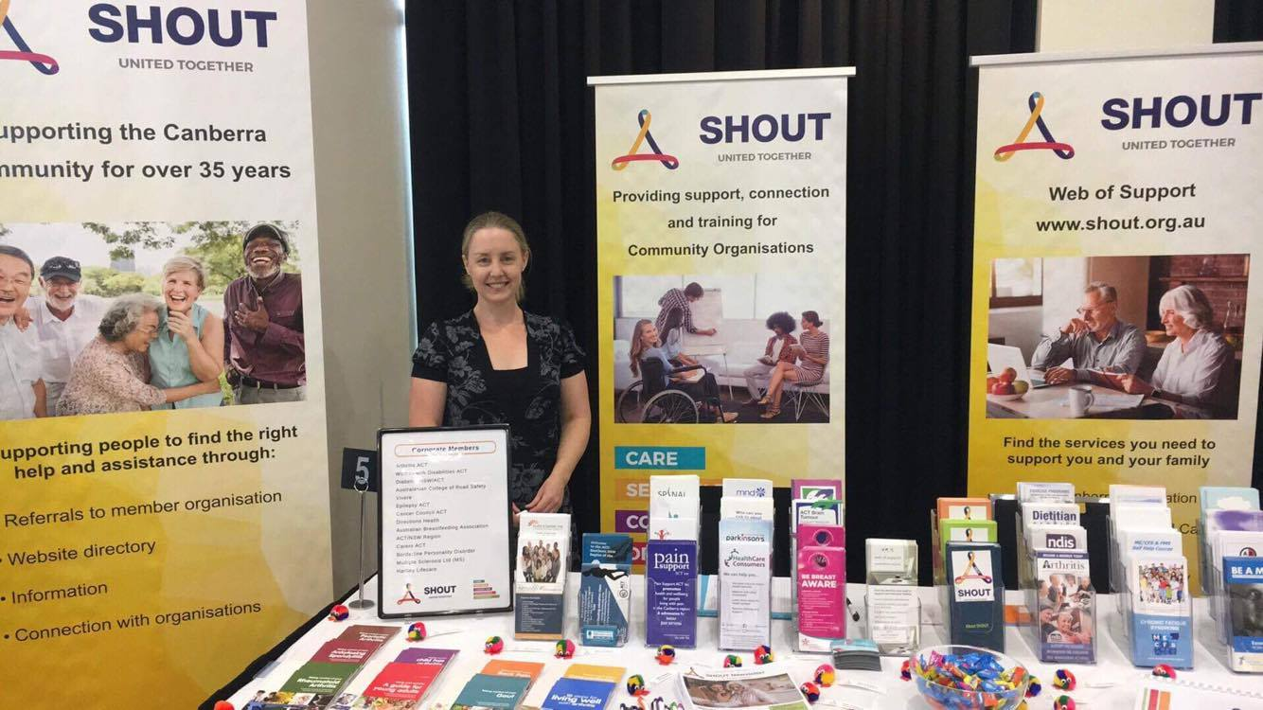
SHOUT Achievements 2019 - 2020

ILC Funding - Web of Support
CSIG Infrastucture Grant – Upgrade of Bosom Buddies and MND Offices
COVID Stimulus Grant - Landscape Pearce Inclusive Community Garden
Community Garden Grant – Build an Inclusive Sensory Garden
CSIG Infrastructure Grant – Supply seating and shelter to the Garden
Well Utilised Administration Support Sevices
Strategic Planning Sessions help for 7 member organisations
Building relationships with MLAs
Raising profile with ACT Government
Development of Community Garden
Re-establishment of the Pearce Coommunity Centre as a hub

Chair Report

Well 2019/2020 has certainly been a year of surprises for us all! SHOUT has not taken any of it laying down – in fact, the innovation and the speedy responses to the needs of the community have been integral to the reasons why SHOUT exists. Before the fridge on the Kings Hwy out of Braidwood, SHOUT was collecting and distributing supplies for volunteer firefighters. Prior to announcements of JobKeeper and cash bonus’ for business, SHOUT was finding innovative ways to support the community through the early days of the COVID 19 pandemic. 2019/2020 gave, and SHOUT responded appropriately, with dedication to our community, and practical means of ensuring those most vulnerable, and those who support others, were supported.
SHOUT had commenced the year with a healthy funding base, but as is with the vagueness of ILC funding, SHOUT was unsuccessful in gaining further funding. This does place SHOUT at risk going into the future with ACT Government funding only providing bare bones funding for SHOUT. Without further support, we do risk losing the momentum, the community presence, that we have worked hard to re-establish over the past 4 years. It will be critical going forward to secure further base funding to ensure the small groups in our community who continue to provide such valuable support to the voiceless in the community

I would like to thank our team at SHOUT for the amazing work that they do for our community. Our CEO, Carol Mead, has set a bold vision for the work of SHOUT and delivers on this consistently. Elsa and Natasha consistently provide our stakeholders with day to day support assisting them in dynamic and innovative ways that constantly exceed the expectations of support from the community.
Our Board have provided strong guidance and strength throughout the year, bringing their own unique talents and experiences from community life to enhance the work that is undertaken by SHOUT.
I want to especially thank Jon Stanhope who is retiring from the Board at this AGM for his guidance and strength over the past 4 years. Jon joined the Board at a time that everyone was leaving the Board. He was not frightened by the precarious position SHOUT was in at the time, and has provided valuable counsel as well as being a strong advocate for the community who still have such a fondness for his work in his time in politics.
Rebecca Davey
Chair

Pearce Inclusive Community Garden

It should be said that if anything positive came out of COVID 19 for the Community it was the Community Gardens at Pearce Community Centre. With the assistance of funding from three areas COVID Stimulus Package - CSD (Community Service Directorate), Infrastructure Grant – CSD and the Community Gardens Grant – Department of Environment. Particularly we would like to thank the two Members of the Legislative Assembly who supported the community in realizing the vision of an inclusive community space – Minister Suzanne Orr and Minister Shane Rattenbury.
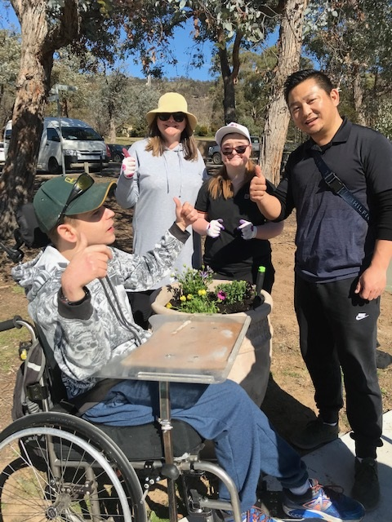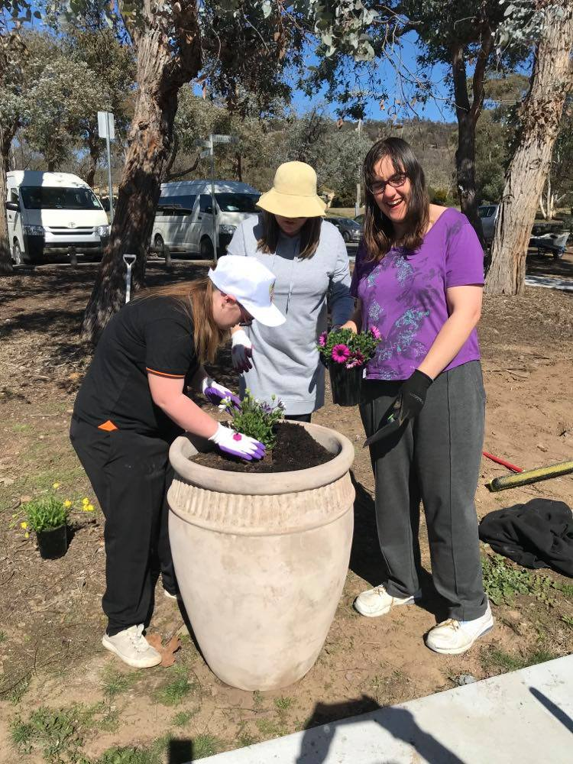
Firstly I would like to thank Suzanne Orr Minister of Disability and her team who saw the immense value of the Garden to the people with disability and the residents in the area who are often isolated and have mobility issues. Suzanne awarded us funding through the COVID stimulus package, which greatly enhanced the way we were able to extend the garden to make it even better than we had planned. The infrastructure grant was also successful and provided the benches and the shelter you see today.
Also I would like to thank Minister Shane Rattenbury and his team, who enabled us to incorporate a vision for an inclusive and sensory garden under the Community Gardens Funding Round. The people with disability who access Pearce Community Centre will be able to spend hours of enjoyment and enrichment in this purpose built garden.
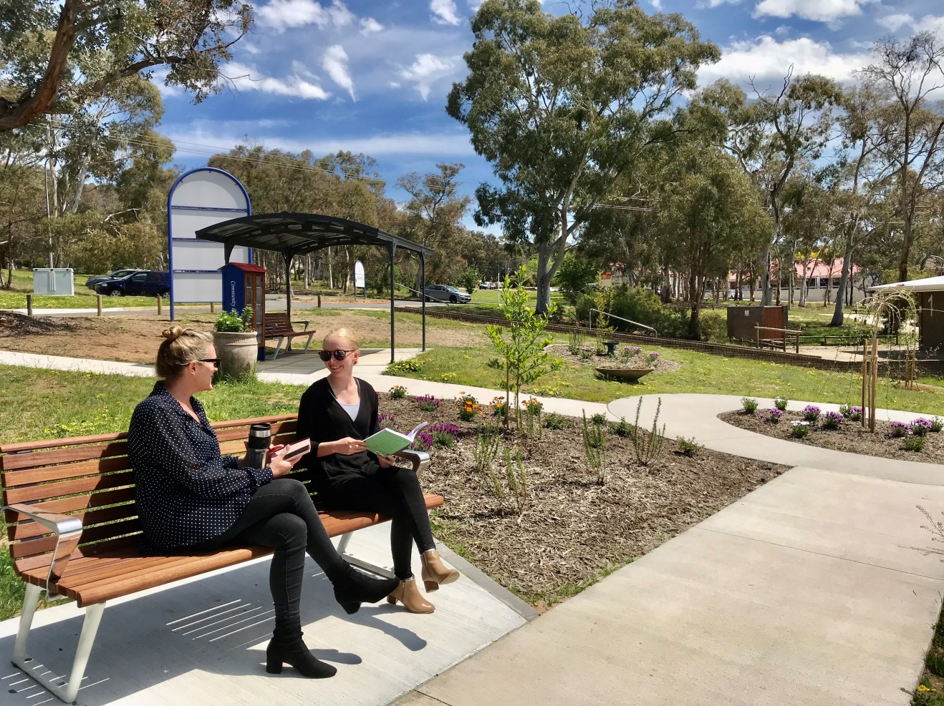
The Pearce Community Centre is a vision of how community and government can work together to provide the Community a place of beauty and connection.
A place to grow things and reduce isolation.
A garden which enhances the lives of people with disability and is focused on what we all can do, instead of what we cannot.
We thank the following people for their support:
- Alistair Bond – who built our wonderful Community Library which offers free books to lend and exchange
- Integral Printing who provided the signage for the Community Library as a donation to the garden
- Joe O’Callaghan of OHomes who donated his time to build the concrete pads for the benches
- And Keiron at Green and Gold Nursery at Gold Creek for providing the planting structure and expertise to make sure the garden is sustainable for the future.
- And lastly I would like to thank the Pearce Community Centre Board, Kiren Lewis the manager of Pearce Community Centre, my Staff and Board at SHOUT, and our stakeholders for their support through this amazing project.

SHOUT Member Survey 2020

SHOUT provides a range of services to the Canberra Community, particularly across health and disability. What are the services that your organisation finds valuable?

SHOUT was set up to support self help groups. How can we add to what we already provide?

What do you see as the strengths for SHOUT to your organisation?
Currently
- Availability of a central address
- Provider (of services)
- Brings different organisations together
- Connection with other organisations
- That it exists – exposure to a network of not-for-profit agencies
- Opportunities for community engagement and growth
- Physical presence when we cannot be present
- Assistance with funding and management support
- Ancillary staff that support Parkinson’s ACT
- Support services, advocacy and advice
- Phone and Liaison Services
- Providing valuable admin support and affordable tenancy
- Advice and templates for god governance
- Access to deep and knowledgeable support
- Strong relationship and connection with the community services industry
- Office and support, treatment space
- Networking, bringing organisations together
- Support for each other’s communities
- Capacity building support and governance support, particularly during tough funding times
- Good welcoming space and collection of like-minded community groups
For the Future
- Availability of central address and support facilities
- Network
- Increasing visibility of organisations for the community
- Community connections and training
- Allowing a greater audience to know we exist
- Continued assistance to with looking for funding opportunities
- Facilitating planning meetings
- Staff support
- Continue as above (4)
- Continue providing valuable admin support and affordable tenancy to ensure we are accessible to our members
- Provision of support staff on an ad hoc basis
- Strategic planning and support to us
- Platform for further expansion into the community services sector
- Meeting space
- Opportunity to grow
- Helping organisations to come together for a shared vision of a more inclusive Canberra
- Good welcoming space and collection of like-minded community groups
For the Community
- One stop shop
- Advocate with ACT Govt for common interests
- Provide caring and effective support
- Support with promotion of our services ad advocacy
- Excellent community space
- Supporting emerging groups to support the community
- Assist with the marketing of our support and info services
- Provide increased exposure of our services
- Ability to connect the local community with our services
- Greater promotion of services and online newsletter via mailchimp or similar
- Helping the community understand what is available to them in their time of need
- Providing community services to people in need – such as mental health
- A welcoming centre for information and support
- Enhanced service directory for support
- Support for those who access SHOUT’s member organisations
SHOUT offers a range of services to its members – if we think about the future of SHOUT what would you like to see?

SHOUT has been successful in achieving funding for an inclusive garden at the Pearce Community Centre, with a longer view of making the Pearce Community Centre a hub for Community activity and events. What would you like to see within the gardens at the Pearce Community Centre?

Our SHOUT Matters Newsletter is produced bi-monthly and we would like to know how valuable it is to your organisation.

Our Web of Support (www.shout.org.au) is an integrated Community Service Directory – how valuable is this to your organisation?

Other Comments
SHOUT Offers well maintained community meeting room at reasonable rates. Staff commitment to communication and support are excellent.
The currently team at Pearce (SHOUT) are highly skilled and more than happy to assist wherever possible. They work closely with myself and other members of the Board such as the President.
A responsive and proactive CEO and friendly staff.



