Annual Report 2018 2019

Name, Job title
Company name
Date
someone@example.com

Chief Executive Officer Report
This year has been in so many ways extremely successful. We secured recurrent funding to continue to operate and also with the addition of NDIS funding we have been stable and in a growth state for much of the year. The website directory ‘Web of Support’ has had an excellent uptake in the Canberra Community with many organisations taking the opportunity to list on the directory and allowing it to grow into an excellent resource.
The NDIS ILC funding assisted SHOUT to continue to develop strategies to further increase the uptake of the website and get the information to the people who need it most. Increasing access up to date information and meeting people where they are has been the challenge of this funding. We trialed many opportunities and have found that the best strategies to communicate with our target audience is to attend events and expos, shopping centre display opportunities and advertise in features in the newspaper. It seems that people are after a place where they can find the information at any time – and the SHOUT website assists them to do this.
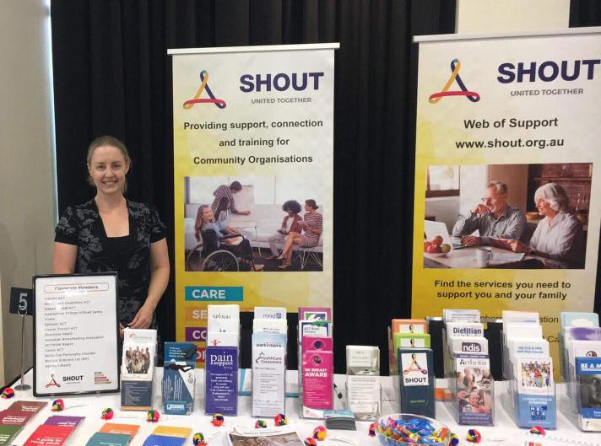
Georgia Kennedy joined SHOUT in January 2018 and has continued through this year giving her expertise and well trained eye to our promotional activities and materials, website and newsletter. Elsa Aitchison was employed in a much needed administration role in July, to support my work at SHOUT and Elsa has been amazing with managing our day to day administration support and working in a permanent part time capacity to other organisations such as Arthritis ACT and ME/CFS Society. Natasha Reardon joined us in June to support Bosom Buddies along with SHOUT. These extremely capable, professional and friendly women ensure the SHOUT office is busy and vibrant. At the time of writing this report we are providing administration support services to support 5 member organisations, building capacity and assisting development.
(continued next page)
This year SHOUT has kept its focus on establishing a robust organisational structure to be able to assist member organisation to build capacity and increase their own capacity to change, strengthen and develop. We have produced a bimonthly newsletter to inform the members about the opportunities, available funding, training and events in the sector. This is increasing opportunities and connection and more organisations join SHOUT every month which is a testament to the raised profile and value SHOUT has in the community.
Providing support for business, funding and governance is now a role in which SHOUT has developed to assist member organisations to further strengthen their business. Consistent and knowledgeable leadership requires these skills and SHOUT supports this at both an organisational level – offering facilitation services for strategic planning days and a managerial level – providing personal strategic guidance and support. This year we have facilitated 4 strategic planning days for member organisations and assisted in countless enquiries to provide advice on governance, business and staffing issues.
In additional to governance support, we are also providing training opportunities to the members through facilitated workshops and training events. We have provided support for the following service training sessions: Critical Conversations; Change resilience and Motivation; and Project Management.
Much of the year was spent with updating the facilities to provide airy and well-designed office space, kitchen facilities and meeting room facilities. Visitors to SHOUT often comment on the facilities and we were happy recipients of the Infrastructure Grant to help us achieve this goal. Most spaces have now been upgraded in line with good practice and OH&S requirements, and have definitely lost the ‘old school smell’ that permeated the facility for many years. In addition small changes, like matching crockery and well used coffee machine, have been very important to value add to the work experience. It certainly is a much nicer place to work and looks so much more professional.
Thank you to Rebecca Davey, SHOUT President, and the Board of SHOUT who have worked at a strategic level to support and strengthen the organisation. It has been great to see the fruits of what was a hard previous year to the strong organisation SHOUT has become. My staff Elsa, Georgia, and Natasha have also been exceptional and are always so engaging with others in so many ways, I am always grateful for their support and competence. I would also like to thank Minister Chris Steel and the Community Services Directorate and Minister Rachel Stephen-Smith for their ongoing support and assistance over the past year.
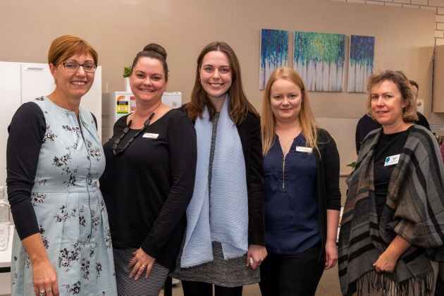
Carol Mead
Our Vision : A fair and just community
which is enriched by self-help.
Our Mission : To support community groups though connection, skill development, awareness and governance to deliver vital outcomes to their members

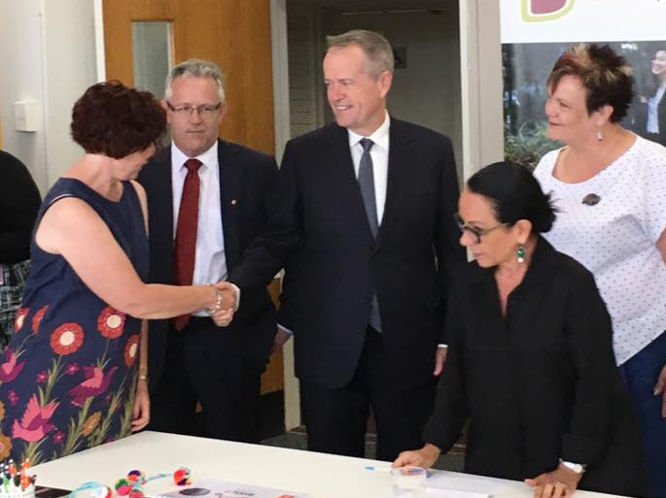
President’s Report
It’s been a refreshing year at SHOUT. We haven’t had to fight for funding, we haven’t had to prove our worth over and over again, and we’re in a position where we’ve rebuilt and it’s all systems go. This is important, because organisations cannot operate in crisis mode all the time. It is unfair to the community to place organisations in that position. Organisations that are in that position will always be inwardly focused no matter what they do, and when they are operating like that, they can’t provide the most to the community they seek to serve. It’s clear now just how stark the impact of the years of unrest were on SHOUT, because it is now a busy, bustling service. In fact, it is so busy we are now becoming almost victims of our own success, struggling to provide that higher level support to the full range of community self-help groups who need the amount of support they need. Being able to provide these groups with adequate support to ensure their governance structures are set up properly from the beginning, to ensure they have the proper planning cycles in the place, review cycles, the ability to market themselves, to grow their market and reach out beyond the boundaries of the known to the unknown, and so those in the community who don’t know they exist, but actually need their support, can find them, is actually very intensive work. This is the type of support that SHOUT exists to provide, and we do it well, and for the right price. It is important that small, self-help support groups of people who have learned the hard way how to survive and thrive, and want to share this knowledge, can have access to this type of support on an ongoing basis and for very low or no cost, because these groups largely do what they do for free, and yet the support they provide to the community is invaluable. This is the work that SHOUT enables to happen, and for us to continue to serve the growing need in the community into the future, we will need to be funded accordingly.
I want to thank our incredible staff for the passion they have brought to SHOUT, the ‘can-do’ attitude they extend every single day. We have the most wonderful online presence, all visitors are met with smiles and respect even when it’s the 100th request for the day for something outside the responsibility of SHOUT. Fixing a lost Word document, assisting someone to learn how to use the printer (again), supporting staff who don’t know how to approach topics that need to be approached with their Boards, doing another quick mail out, helping someone craft a media release that will have an impact on the community, nothing is ‘too much’ for our staff. Carol, Elsa, Georgia and Natasha, the work you do reaps so many rewards to the Canberra community, and we are very very lucky to have you all.

Finally to the Board – it’s not always fun sitting on a community Board, in your own time, for no payment except probable ‘could you just do for us…’ requests that can often be awkward, thank you. Thank you for turning up meeting after meeting, for being willing to put yourself out for SHOUT and the community we serve.
Rebecca Davey

Board Members 2018/2019
Rebecca Davey - President
Jon Stanhope - Vice President
Khalid Ahmed - Treasurer
Peter Moore - Secretary
Libby Steeper – Board Member
Shannon Kolak – Board Member
Linda Spurrier – Board Member
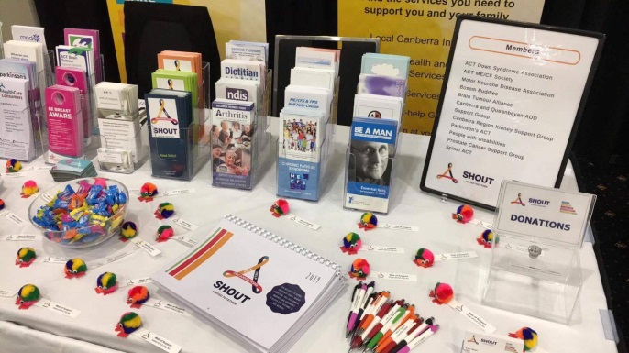
Acknowledgments
SHOUT would like to acknowledge the following businesses for their support and assistance throughout the year.
Lan ID
Logical Solutions Australia
Pearce Community Centre
Nexis Accounting Services
O’Halloran Homes
Zsuzsa Painting
Queanbeyan Carpets
Sedcom
Our Purpose is to support and connect
community groups with the Canberra Community by building capacity and opportunity.
Wax
Raymond Mac Neill Photography
Mackmore Cleaning Services
Vincent’s Auditors
Archie’s Plumbing
Mick Burrows Electrical

Members of SHOUT Inc.
Our membership has continued to grow throughout the year and we are grateful for their confidence, feedback and support.

Corporate Members - 18 | Full Members - 10 | Affiliates- 14
# ADACAS | * ACT Down Syndrome Association Inc | ACT Deafness Resource Centre
# Advocacy for Inclusion | *ACT ME/CFS Society | Adoptive Families Association ACT
* Arthritis ACT | *Bosom Buddies | AIRA
Australian Breast Feeding Association ACT NSW Region | *Brain Tumour Alliance Australia | Al-Anon Family Groups Australia ACT
Australasian College of Road Safety | Canberra Queanbeyan ADD Support Group | Better Hearing ACT
# BDP Awareness | *NSW ACT Motor Neurone Disease Association | Canberra Region Kidney Support
# Cancer Council ACT | Parkinson’s ACT | Hemophilia Foundation ACT
Carers ACT | * People with Disabilities ACT | Healthcare Consumers Association
Diabetes Association NSW ACT | Prostate Cancer Support Group | Hepatitis ACT
Directions Health | Spinal ACT | Lunglife Support Group
Epilepsy ACT |  | Mental Health Foundation ACT
# Flourish Australia |  | # Mindful Self Compassion
# Hartley Lifecare |  | # Sharing Places
# Multiple Sclerosis Australia ACT |  | Sleep Apnoea Association ACT
#PANDSI
# Personnel Group
# Retire Invest
Women with Disabilities ACT

New members for 2018/2019 #
Tenants noted with *

Member Survey Results 2018/2019
The survey of SHOUT was answered by 25 member organisations across the ACT. The survey was open for 4 weeks and approximately 50% of SHOUT members responded via a survey monkey platform.
Question 1
SHOUT provides a range of services to the Canberra Community, particularly across health and disability. What are the services that your organisation finds valuable?

Question 2
SHOUT Membership is available in three categories, which membership does your organisation hold?

Question 3
SHOUT was set up to support self-help groups. How can we add to what we already provide?

Question 4
SHOUT provides a range of training opportunities for managers, volunteers and boards. Has your organisation taken part of this training?

Question 5
What would you like to see in the future for SHOUT?

