**Looking for something to give Mum for Mother’s Day?**

**A gift donation – we will send you a card or certificate that you can present to your Mum for Mother’s Day (and it’s a tax deduction).**

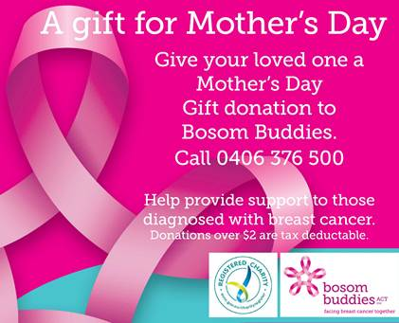

**An entertainment book – the book that gives all year round!!**

**[](https://www.entertainmentbook.com.au/orderbooks/2423j3)**

**What about a Bosom Buddies keyring @ $5 each:**

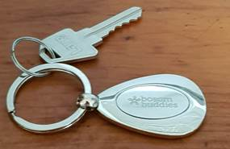

**Are you or your Mum about to take a trip?  Our new bra travel case might be the perfect idea @ $20:**

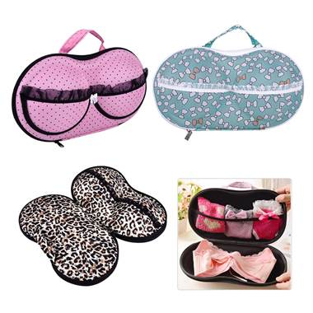

**We still have our Bosom Buddies stubby holders @ $5 each:**

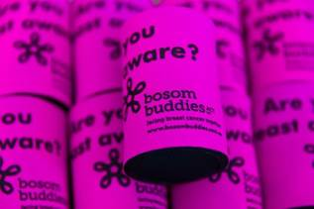

**If any of these great ideas take your fancy give me a call on 0406 376 500.**

**Kareen Tait**

**Executive Officer**

0406 376 500 ● 6290 1984 ● [www.bosombuddies.org.au](http://www.bosombuddies.org.au) ● Monday to Thursday ● 9.30am – 2.30pm

