Annual Report 2017/2018

Name, Job title
Company name
Date
someone@example.com

Chief Executive Officer Report
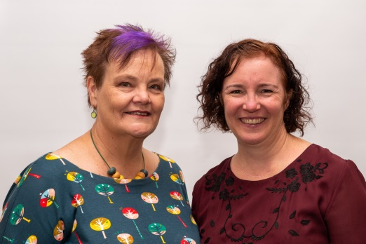
As I began at SHOUT in late August 2017, I have had almost a full year to reflect upon for this annual report. I came into an organisation which was offering services to tenants and members and which had a great amount of support from the community to continue, despite a very rocky 2016-2017 period. I thank Phoebe Star and Mandy Hudson for all their work and keeping the organisation solvent in very tough times. They left a good legacy to build upon, and for that I am so very grateful.
After regrouping and creating a vision of what SHOUT could be, we set time aside to revamp the organisation, and the facilities as much as we could with a limited budget. The meeting room was one of the first to be completed as we rent it out to members and the community sector, and we certainly needed to upgrade it to a more cohesive and appealing space. This has been successful with more organisations using this space than before and as I write this – we are almost breaking even – which certainly was not the case one year ago.
Bringing around change has not been an easy road, however there was a knowledge that SHOUT could not continue as it was, and certainly would not have received funding to continue do so. A new model was implemented by the Board which targeted supporting and building the sector, working on building capacity and strengthening organisations, and assisting them to navigate through the mire that is governance.
We also made some difficult decisions at that time to change the pricing structures for our members for tenancy, meeting room rental, cleaning, photocopying and made the decision to rent out the small meeting room which was operating at a significant loss. These changes were difficult and I thank all the members for their understanding through this time as we brought about much needed change.
Within our work at SHOUT we now have in place regular training, round tables and capacity building activities. Particularly well attended was the governance training that SHOUT sponsored for Members. Personally, I am very proud that the community of members sharing knowledge, seeking assistance for funding applications and governance issues has risen significantly over the past year. A safe space is provided for organisations to connect, share and develop.
Of course it was not all roses, and it must be said that some members were not happy with changes, particularly when we were not able to give the free administration support that they had previously enjoyed. We are still negotiating about our services, but now offer them at an hourly charge, to pay our costs.
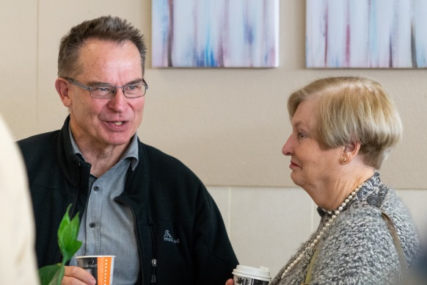
While working with the Board we developed a business and marketing plan to make in-roads in raising SHOUT’s profile. This is definitely a work in progress and there is still much to do. My aim is definitely to strengthen the Self-Help sector and support community organisations with the belief that together we are stronger. On the whole we have found encouraging signs that community groups respond to SHOUT and while the next year will further strengthen this resolve, our profile is increasing.
A mission this year has been to meet with the members and we have developed a third tier of membership – Corporate Membership. Many organisations were Affiliate Members but wanted more – and SHOUT needed their strength and expertise to assist in developing the sector. This has been very successful with 10 corporate members joining to date.
The NDIS ILC funding assisted SHOUT to develop a very user friendly website and we launched this is May 2018. Throughout its development we rebranded the organisation and now have a unique identifiable logo. The Web of Support will continue to grow with input from organisations and we are now widely promoting this in the community.
While this year was a year of change, development and restructure, we are now in a much better place to continue raising the profile of SHOUT in the year ahead. We have now secured funding for the next 4 years from ACT Government and have also been successful in gaining NDIS ILC funding for another 12 months. The challenge will be to further secure SHOUT into the community and gaining project and other funding if the NDIS funding is not renewed for 2019.
Thank you to Rebecca Davey, SHOUT President, and the Board of SHOUT who have worked tirelessly to bring the organisation back from the brink of being defunded. I am looking forward to a great year ahead, and I also would like to thank Minister Rachel Stephen-Smith and our amazing Members for your support and assistance over the past year.
Carol Mead
President’s Report
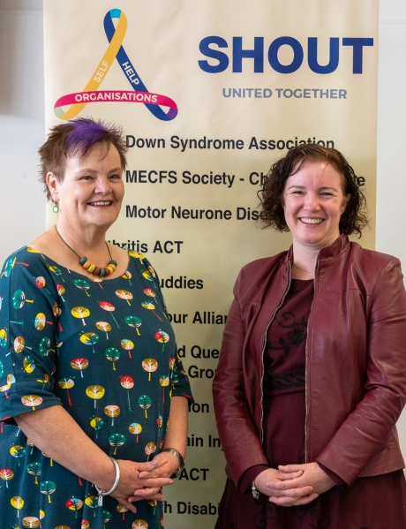
The financial year began with many questions as to SHOUT’s future that were still to be resolved, and has ended with SHOUT being firmly ensconced into its place in the Canberra NGO landscape with a clear purpose, a growing utilisation from the community and a clear mandate to extend our support to those who need us the most – the most vulnerable members of our Canberra community.
Helping us achieve all we have this year has been the guiding force of our Minister for the year, Rachel Stephen-Smith. To Minister Stephen-Smith, I say thank you for really listening. Not only did she listen, but she identified issues and helped us to transition from Disability to Infrastructure, and to put the processes in place that would ensure a base that would allow us to continue to grow. When systems Government had thought would assist us failed to deliver, the Minister again listened, and worked with us to ensure SHOUT would grow and develop in relation to the need of the community, not the systems thought useful by various types of bureaucracy.
This year has brought with it a new level of staffing. To manage the changes we had to make, we needed people who had the fortitude to make the changes. We know there are some out there who would have preferred we had not undergone such change, but had we not, we would have no longer existed. At least the nay-sayers have a place they can come to complain about change – had we followed that path they would have preferred they would have lost their place to support their people. It has not been an easy job for our Change Management Agent now CEO Carol Mead. There have been times she has had to be tough and simply say no. There have been incredible changes in the physical appearance, and more importantly, the atmosphere at SHOUT. It has gone from a series of closed doors and isolated organisations to a community of organisations who collaborate, learn together, and laugh together. Everyone is working stronger and smarter for the combined community that we serve, and the community are receiving better services and experiencing better outcomes as a result of this collaboration.
Our NDIS funding was a key component to our change during the year. The new Web of Support provides pathways, not just for individuals, but also for the small self-help groups that operate in every part of our community. Volunteering groups who exist for no other reason than to share their experiences to support others need also to be supported. No group is too small nor insignificant for SHOUT to assist, and we know that by assisting them to lay down their frameworks of governance early that they blossom, and the outcomes they produce in this community of ours increase in magnitude.
To our members who have been prepared to work with us and have enabled this change to occur, thank you. To your Boards who have listened and learned from our experiences, well done. To the wider community who continue to support the work of SHOUT in so many ways, through your lobbying, your advocacy and your time, thank you. A stronger SHOUT means a stronger Canberra community.
Finally, to our staff who have put up with a lot this year, thank you. Carol, the woman of a thousand ideas, and the ability to deliver on each and every one, thank you for the colour and vibrancy you have brought to the community. To Georgia, who worked tirelessly ensuring the background work of the Web of Support came to fruition, thank you! It was a huge project, and we had a huge point to prove by getting it to launch before the end of the financial year, and you did it. To Elsa who joined the team just prior to the end of the financial team, your quiet caring and ability to just get in and run, amazes us.
Rebecca Davey
President

Statement of Purpose
Our purpose is to support and connect community groups with the Canberra community by building capacity and opportunity.
Vision
A fair and just community which is enriched by self-help.
Mission
Our mission is to support community groups through connection, skill development, awareness and governance to deliver vital outcomes to their members.

Board Members 2017/2018

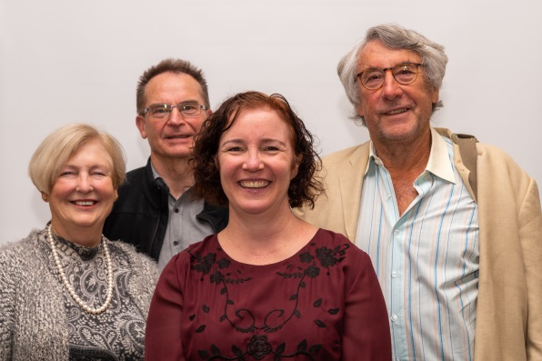
Rebecca Davey - President
Jon Stanhope - Vice President
Khalid Ahmed - Treasurer
Peter Moore - Secretary
Libby Steeper – Board Member

Members of SHOUT Inc.
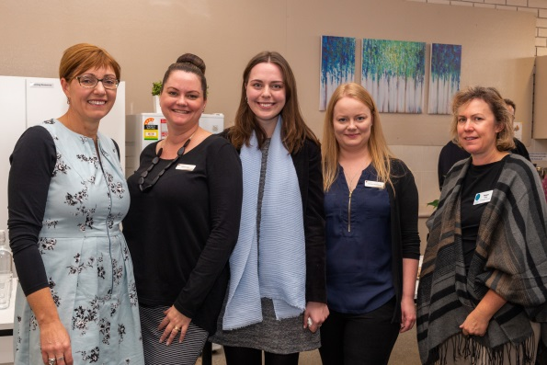
Full members of SHOUT
Corporate members denoted with**

ACT Down Syndrome Association Inc
ACT ME/CFS Society
Arthritis ACT **
Australian Breast Feeding Association ACT NSW Region **
Australasian College of Road Safety **
Bosom Buddies
Brain Tumour Alliance Australia
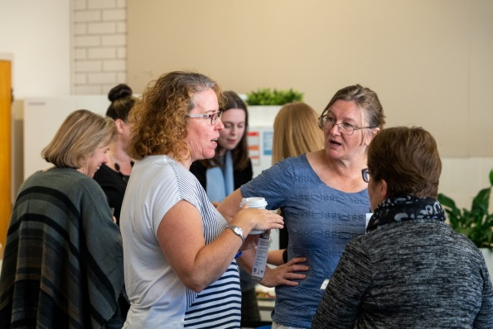
Canberra Queanbeyan ADD Support Group
Canberra Region Kidney Support
Cancer Council ACT **
Carers ACT **
Diabetes Association NSW ACT **
Directions Health **
Epilepsy ACT **
Friends of Brain Injured Children
NSW ACT Motor Neurone Disease Association
Parkinson’s ACT Spinal ACT
People with Disabilities ACT Vivre **
Prostate Cancer Support Group Women with Disabilities ACT **

Web of Support
Through the NDIS ILC funding SHOUT spent much of the year developing the website called the ‘Web of Support’
The launch on 22nd May 2018 was very successful with a wide range of our members attending and 4 Ministers. Rachel Stephen-Smith officially launched the Web of Support and we continue to spread the work throughout the community. We thank the Minister for her ongoing support.
In addition an article for the web of support has been written to highlight its unique value for the Canberra Community. Published in the Canberra Times:
Joining a self-help group can be empowering for people with a chronic illness or disability, providing essential support and help to combat isolation.
Self-help groups or support groups refer to people who share a common condition, illness, disease or addiction and come together regularly to provide mutual support for one another.

Joining a self- help group can help reduce stress and feelings of loneliness through sharing of information and experiences and receiving support from people who know what they are going through. In Canberra there are hundreds of self-help groups which support thousands of people and their families who have a variety of conditions or disabilities.

“Self-help groups are very empowering for someone who has a chronic Illness or disability. It makes them feel part of a community,” says Carol Mead, chief executive officer of Canberra’s community organisation SHOUT. “Any form of chronic illness is isolating and when you realise that others are dealing with very similar issues and have ideas and strategies which help them cope that they can share, it’s an absolute relief to have that support,”

People looking for a self-help group in Canberra can access this information through SHOUT’s “Web of Support” directory on its website www.shout.org.au.

The online platform assists people with finding the services they need for their health and also connects them with relevant self-help groups in the region. SHOUT is funded through the ACT Government and NDIS to provide support and build capacity within self-help community organisations, specifically working with the disability and health sectors.

As well as linking people with self-help groups, the Pearce based organisation provides support, expert advice and resources for more than 40 self-help members. Services SHOUT provides to members include governance and strategic direction, risk management and resource management.
SHOUT’s membership is broad and includes a range of self-help groups such as Under 5’s Parent Support which assists parents of children with Down Syndrome, Bosom Buddies which supports people who have had breast cancer and People with Disabilities which works alongside other disability organisations to provide support and advocacy.

“People are looking more and more these days to the web rather than picking up a brochure. It really helps to be able to have access to information at your fingertips at any time,” Ms Mead says.“Self-help groups are a very important part of dealing with any condition including chronic illness and also with recovery from drug and alcohol dependency. They work well alongside a medical model.”

“Being part of a self-help group can reduce a person’s feeling of isolation and help them connect with others who are in the same or similar situation,” she says. “They reduce dependence on medication and give people a real purpose to help others with the same condition as them.”

The groups also give people an outlet where they can talk about their condition to people outside of their family. A lot of groups also provide support for the extended family too.

“Not only is it giving people different strategies to help with their chronic condition, people can also share things with others who understand them through their own experience.”

“Self-help groups do so many things to connect people and strengthen people to be able to cope with their illness or disability,” she says.

A lot of groups also provide support in different ways such as conference calls, Skype and Facebook, which help people who may have trouble leaving their home.

Acknowledgments

SHOUT would like to acknowledge the following MLAs for their ongoing support over the past 12 months:
Rachel Stephen-Smith
Elizabeth Lee
Jeremy Hanson
Alistair Coe

SHOUT acknowledges these following businesses for their support and assistance throughout the year:

Lan ID
Logical Solutions Australia
Pearce Community Centre
SMS Consulting
Nexis Accounting Services
O’Halloran Homes
Zsuzsa Painting
Queanbeyan Carpets
Sedcom
Wax
Raymond MacNeill Photography
Vincents
Mick Burrows Electrical
Archie’s Plumbing
Queanbeyan Carpets

SHOUT acknowledges the support and concern of many groups and individuals in the Canberra Region throughout the past 12 months – especially through this time of change and growth. It has been increasingly apparent over this time how important the institution of SHOUT has become to the community and the support that it continues to grow and build organisations throughout the region.

Member Survey Results December 2017
In the past 6 months how have you found the changes at SHOUT Inc.?

It is now a very professional organization and more organised with premises updated. Physically a more pleasant environment, communication re other agencies, events as good as it was previously.
SHOUT looks more organised and professional. Communication with groups is good. Changes have been made which clearly are required to keep SHOUT viable.
Q2 What is Important for your Organisation

Q3 What seminars would you like offered to you?

Q4 What can SHOUT do better for your organisation?
- We are very happy with all that SHOUT is currently doing to support us
- Doing a great job for us!
- Help (paid) with employment arrangements and pay of employees. Possibly office space in the future. Information on funding opportunities. Availability of a smaller meeting room if possible.
Q5 What do you see as SHOUT’s Strengths?
- A voice for the SHOUT members
- Professional support across a wide range of areas is always available. It acts as an advocate for small groups who would otherwise be voiceless.
- Commitment to sharing information, making information accessible to the public, supporting small agencies to be successful in administering their organisation
- Supports and mentors small organisations such as Spinal ACT. Disseminates information. Provides a contact point, postal and physical addresses and a phone number for small community not for profit organisations.
- Providing support to voluntary organisations with differing needs.
- Current network of organisations.
- Ability to be a focal point for self help. Visibility
- A one stop contact point and dissemination arm for many community support groups. A one stop shop to help organisations with issues which they face in doing their work - so that not every organisation needs to re-invent the wheel. The centralising of such advice and assistance saves the time of volunteer organisations so that they don't burn out and can devote more of their time to helping vulnerable people rather than to admin.
- It can be a voice for NGOs who are currently sidelined by the NDIS. It is the only NGO support organisation in the ACT.
- A community of like minded community sector organisations supporting each other. A focal point for the provision of complex administrative and governance support services to small organisations.
Q 6 What do you think SHOUT can improve on?
- Maybe a better link to Government funding. As previously discussed its better for one organisation to request funding for others rather than all of us approaching the Government.
- The improvements that were needed are happening.
- More member NGOs will give it strength. And Shout can develop its public profile to raise awareness of the sector
Q7 If you are a tenant of SHOUT – Is SHOUT meeting your organisations needs?
Very Much 33.33%
Yes 66.67%
Q8 Anything else to add?
- With strong, creative leadership SHOUT is now putting into place best practices and it will continue to grow under the present CEO
- Thank you for doing this work to keep a vital organisation going!
- very constructive survey should be valuable to the board in working on its restructuring

